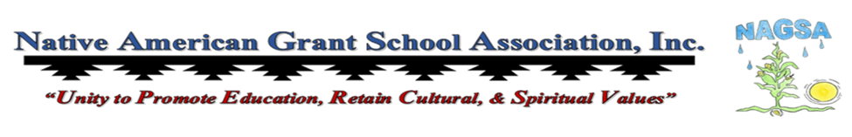

Winter Conference announcement
Call to Vendors

December 11 – December 13, 2025
Tuscany Suites & Casino
Las Vegas, Nevada

“Effectively Upholding Student Education on all Levels: Federal, State, & Tribal”

Native American Grant School Association presents the 2025 Winter Conference on Thursday, December 11 through Saturday, December 13, 2025. The Winter Conference will be held at the Tuscany Suite & Casino in Las Vegas, Nevada. The focus theme for our Winter Conference is: Effectively Upholding Student Education on all Levels: Federal, State, & Tribal.

- We are limited on vendor spaces. All vending spaces are first come first serve base.
- Vendor Fee will be $150.00 for 3 days.
- Vending spaces will be 8 feet, additional space will be additional $50.00 per day.
- NAGSA will not reserve vending space until full payment is received.
- No refunds will be honored for no shows.
- NAGSA is asking all vendors to not to sell any food or drinks, including baked goods per
- hotel policy and agreement.
- NAGSA and Tuscany will not be responsible for any lost, damages to items of the vendors.

Please email Tom Franklin, Jr. tfranklinjr01@gmail.com with your contact information with topic.

winter Conference
Vendor Registartion

December 11 – December 13, 2025
Tuscany Suites & Casino

“Effectively Upholding Student Education on all Levels: Federal, State, & Tribal”

Vendor:
Mailing Address:
Phone: ( ) | Email:

Vendor Type: Company Education Resource Jewelry/Crafts Other
Vendor Fees:
$150.00- 3 days $50.00 for additional space for 3 days ($150.00)

Registration must include full payment to be completely processed, no Purchase Order at this time.
Check:_________________________ Money Order:_____________________________

Vendor Agreement with NAGSA Conference Planning Committee
- We are limited on vendor spaces. All vending spaces are first come first serve base.
- Vendor Fee will be $150.00 for 3 days.
- Vending spaces will be 8 feet, additional space will be additional $50.00 per day.
- NAGSA will not reserve vending space until full payment is received.
- No refunds will be honored for no shows.
- NAGSA is asking all vendors to not to sell any food or drinks, including baked goods per
- hotel policy and agreement.
- NAGSA and Tuscany Suites & Casino will not be responsible for any lost, damages to items
- of the vendors.

____________________________ ___________ ____________________________ ___________
Vendor Date NAGSA Date

